WHAT IS THE ROOT OF THE STRUGGLE IN THE MIDDLE EAST?
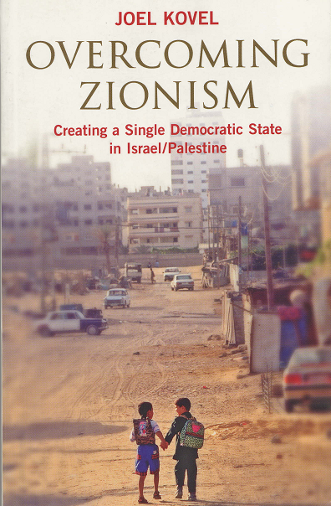
LECTURE AND DISCUSSION WITH JOEL KOVEL

FRIDAY, MARCH 28TH
7:00 PM
GRACE PLACE
637 S. DEARBORN ST.
CHICAGO

Joel Kovel, author of numerous books and professor at Bard College, will be discussing his latest book Overcoming Zionism: Creating a Single Democratic State in Israel/Palestine.

In 2007, the Israeli lobby made an all out effort to prevent this book from being published in the United States. Due to an outpouring of protest, the University of Michigan press reversed it decision and published Kovel’s book..

Kovel’s unvarnished analysis of Zionism will be the topic for discussion.

PLEASE COME AND JOIN IN THIS IMPORTANT DISCUSSION.

Sponsored by the American Friends Service Committee – Chicago, International Solidarity Movement – Chicago, National Lawyers Guild – Chicago, the Palestine Solidarity Group and Students for Justice in Palestine.

For information, email: contact@nlgchicago.org

Refreshments will be provided.

