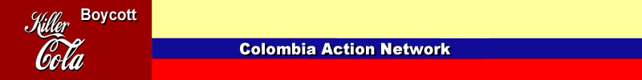
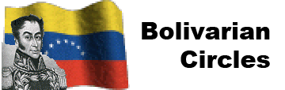
No Blood for Oil! In Iraq, Venezuela, or Colombia!
Defend the pro-people Bolivarian revolution in Venezuela!
End the U.S. government’s deadly Plan Colombia!

End US Imperialism
in Colombia and Venezuela!

A night of Solidarity with Colombia and Support for the Bolivarian Revolution in Venezuela

Sunday November 6th, 6:00 PM
Casa Michoacan
1638 S. Blue Island Avenue

by

Bolivarian Circle of Chicago
Colombia Action Network

Erika Zurawski
Erika is a member of the Colombia Action Network and participated in a US delegation to Colombia this summer. The delegation met with human rights organizations, labor unions and campesino (peasant) groups to investigate the true effects of US military aid to Colombia.

Rixio Barrios
Rixio is a member of the Bolivarian Circles of Cincinnati. He was part of the Ground team for the International Youth and Student Festival in Caracas this summer, and he was an initiator of the Bolivarian contingent at the September 24th demonstration against the Iraq war in Washington DC.

